Vagmi, Akshay, Ananya, Bishoy, Dylan

Business Intelligence

20 November 2023

Project Topic

The company we choose to research for our upcoming term project is Amazon. Amazon is a multinational company located in Seattle, Washington, that specializes in e-commerce in the industry. While they are known for their cloud-computing and artificial intelligence, we’re focused on what makes the e-commerce of Amazon and the products they offer so robust. Amazon offers over 12 million products and thousands of different departments. We are curious to create potential BI solutions for Amazon because we have large amounts of data at our disposal. Attached are Kaggle links of datasets that we plan to develop dashboards for, and have many more under consideration, if we plan to explore such topics (i.e. online advertising and streaming services).

<https://www.kaggle.com/datasets/lokeshparab/amazon-products-dataset>

<https://www.kaggle.com/datasets/karkavelrajaj/amazon-sales-dataset>

<https://www.kaggle.com/datasets/datafiniti/consumer-reviews-of-amazon-products?select=1429_1.csv>

Slide Deck Template:

* Description of Amazon
  + Do they use MS Excel or any database platform <- Bishoy wrote a little (did some search)
  + Data Sources Folder
* What Area of Amazon We’re Trying to Study
  + Customer Reviews
  + Product Sales and Ratings
* Datasets we did work on
  + One dataset is Customer Reviews and the other dataset is Product Sales and ratings
  + Both are separate datasets and were not combined
  + Amount of information in dataset A (80,000+ rows)
  + Pairwise or listwise deletion?
  + Dylan -> Separate Categories
    - 7 different categories
    - Clean and use different categories for the dataset
* KPIs
  + Dataset 1:
    - Total Revenue Per Category
    - Product Performance
  + Dataset 2:
    - Customer Review and Ratings (Satisfaction and Engagement)
    - Inventory Stock Status
* Dashboard

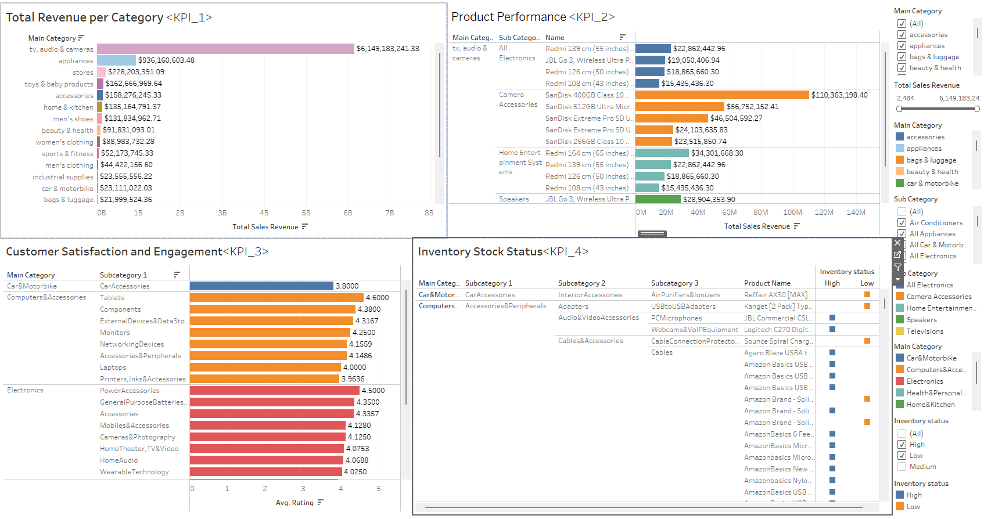

* Limitations
  + The 3rd dataset didn’t fit what we’re trying to convey (pretty redundant since the first two)
  + Attempted to find a discount KPI but missing one of the joins on Tableau and couldn’t create category we needed
* Summary
* Questions